**Year 13 Digital Technologies – Dynamic web design project**

**The process**

**Stage 1: Coming up with a design:**

**Website:**

**Implication**: Usability

**What it is** Usability? Usability refers to how easily a user interacts with a website. In Usability I found that designers have three main aspects they focus on. Firstly, it should be easy for the user to become familiar with and confident in using the user interface during the first contact with the website. Secondly, it should be easy for users to achieve their objective through using the website. In my case if a user has the goal of buying a type of sneaker, a good design will help guide him/her through the easiest process to purchase that sneaker. Thirdly, it should be easy to recall the user interface and how to use it on future visits. So, I think a good design of a sneaker store the user would learn how to buy a shoe and be able to replicate that again for their next purchase, just as easily as the first time.

**Why is it important to your project**: Usability is very important to my project. The main reasons for this are that my website needs to sell products to the users that visit the website. The website is a retail store, so if it does not follow the relevant implication of Usability then users will struggle to find their way to purchase any products from my website. Having this relevant implication means users will be able to browse through my website with ease and be able to make purchases with no trouble.

**How will you address it**: When designing my website, I will make sure to focus on the main aspects of this relevant implication, so I become successful in this implication. I will make sure my website is easy to use and users can feel confident when they browse on it. I will make sure users can easily achieve their goal that they have on my website, which will include user error so if they make any mistake my website will be able to deal with the problem and put them back on the right path to achieve their goal and finally I will make sure my website is easy to remember making it look good but simple so my users can remember how to achieve their goals once they come back and revisit the site. My site will be clear and simple so users can easily navigate around my site. I will have a consistent layout I will do this by following my research that I will conduct allowing me to have similar design features such as navbar, search bar, and product layout being similar to other websites so users will be able to use their prior knowledge of how other existing sites work.

**Implication**: Aesthetics

**What it is** Aesthetics? Aesthetics is a relevant implication that focuses on the beauty and taste of a website or product. Studies have proven that creating a good aesthetics in a product or website leads to better usability and user experience. Aesthetics is important because it impacts the user experience of a website in several ways.

**Why is it important to your project**: Because my website is in the retail niche, I need to do everything I can to have users be interested and be engaged with my product. From my research I found that have an aesthetically pleasing website it will increase the user experience which will create a higher chance for them to purchase something from my store.

**How will you address it**: I will address this relevant implication by making sure my website is well designed and is aesthetically pleasing for a user to use. This will mean that when a user looks at my website, they look at it and know exactly where everything is because it is well laid out and looks good. If I combine both Aesthetics and Usability my users will be able to navigate my website with easy because it not only looks good but is very useable. I will achieve this by choosing a good-looking colour scheme that has contrasting colours, so users enjoy looking at my site. It will be uncluttered so the user does not feel cramped and over exposed to content by doing that I will have clear navigation so my users can easily navigate around my site with ease.

**Data Base:**

**Implication**: Functionality

**What it is:**  Functionality refers to now useful your outcome is. Whether its for a website or database it has the same meaning. When setting up my data base I need to ask myself these questions to make sure I am following the implication. How useful is your outcome? Does it do what the client wants? How do you know? Can anyone use it? Could testing help ensure that your outcome is functional? Do people know how to use it?

**Why is it important to your project**: Functionality is very important to my website. This is because functionality is the backbone to every website, if the website is not functional then nothing works which means no users will purchase anything from my retail store. I need to make sure my database is functional and working so it connects to my website correctly. This will mean it will display the correct information (text, images etc.) Once I have done this then I will have completed the relevant implication.

**How will you address it**:  When addressing this relevant implication, I will be asking myself these questions. How useful is your outcome? Does it do what the client wants? How do you know? Can anyone use it? Could testing help ensure that your outcome is functional? Do people know how to use it? These will help me follow the relevant implication, making sure the database is functionable and working so it does not negatively affect the site. My database will be able to filter brands, enables my cart and user accounts (adding productid’s to an userid so their content can be saved in their cart even when they log out.) My site must have a database, or it will simply not work.

**Implication**: Legal

**What it is**: Legal relevant implication refers to well as the name states, the legal side. Basically, any various products can have some commercial value. This pretty much means I cannot go steal someone else’s image and put it on my site without have that person’s permission to do so. If I were to steal someone’s content and claim it as my own that would now become illegal and the persons content, I stole could retaliate back towards me.

**Why is it important to your project**: This is one of the most important out of all the relevant implications. This is because a website can not have illegal content on its site, or it will risk being taken down.

**How will you address it**: I will address this implication by using my own photos and content. I will design the logo and take all the photos myself. I can design the logo because I take design and have the applications to design a logo photoshop etc. I can also take the photos myself because I have a rather large sneaker collection so I can just take photos of them as it will not using someone else’s content.

**Proof of research:**

As a teenage boy I am already well a where of what ecommerce sites are like such as Nike, adidas and puma which I have based my designs around. Some screenshots below will be how I will base my site. Focusing on design aspects e.g. how nav-bar, search, login, register is laid out so the user will already know where these things are without even looking at the site making it easy to use and navigate.

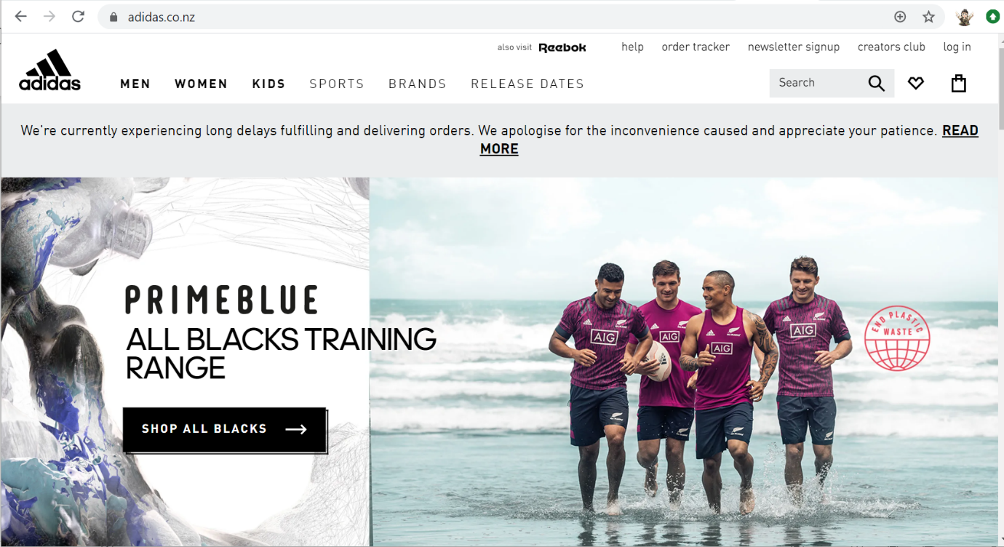

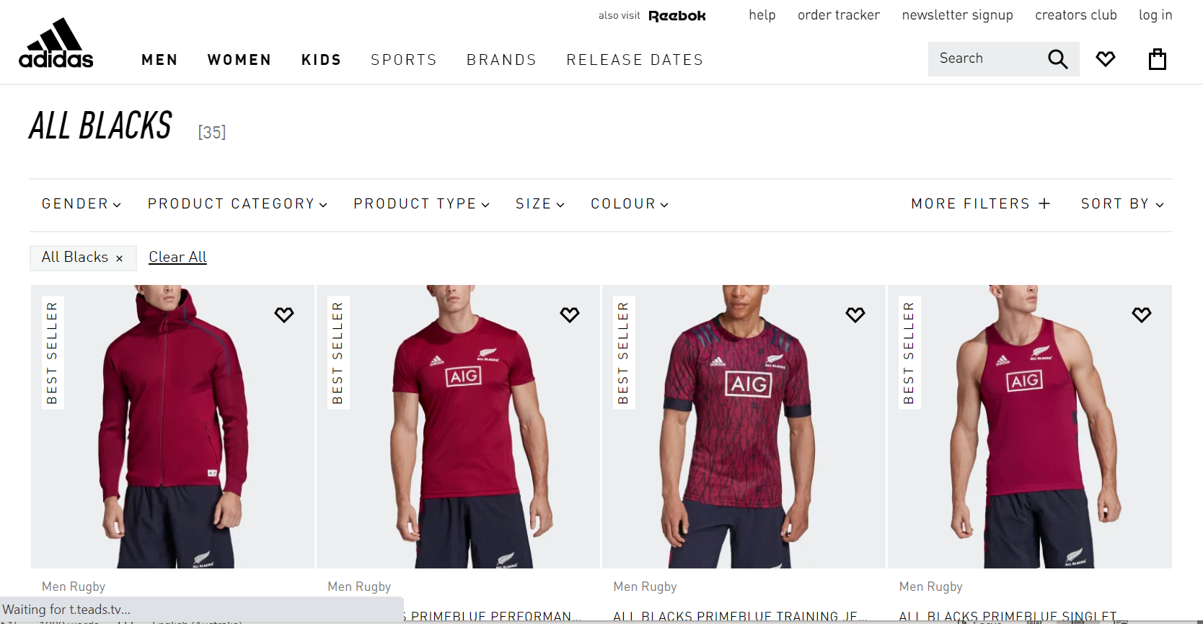

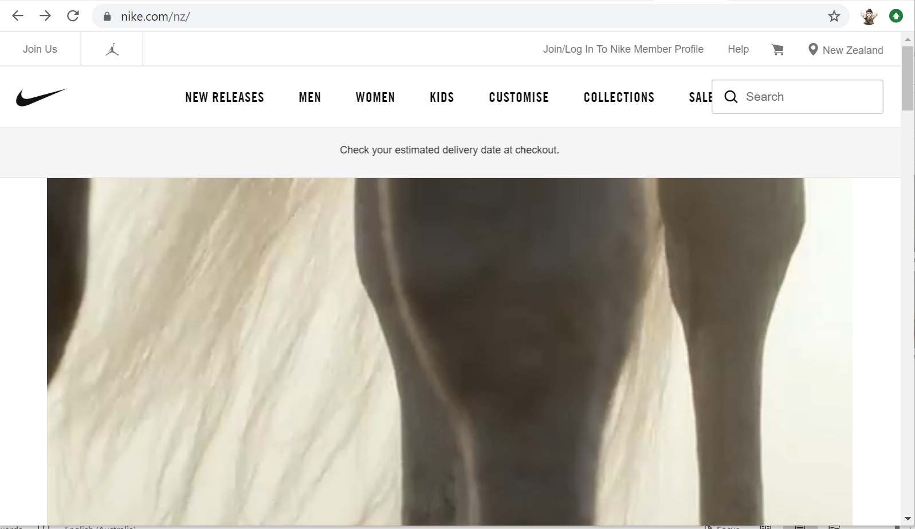

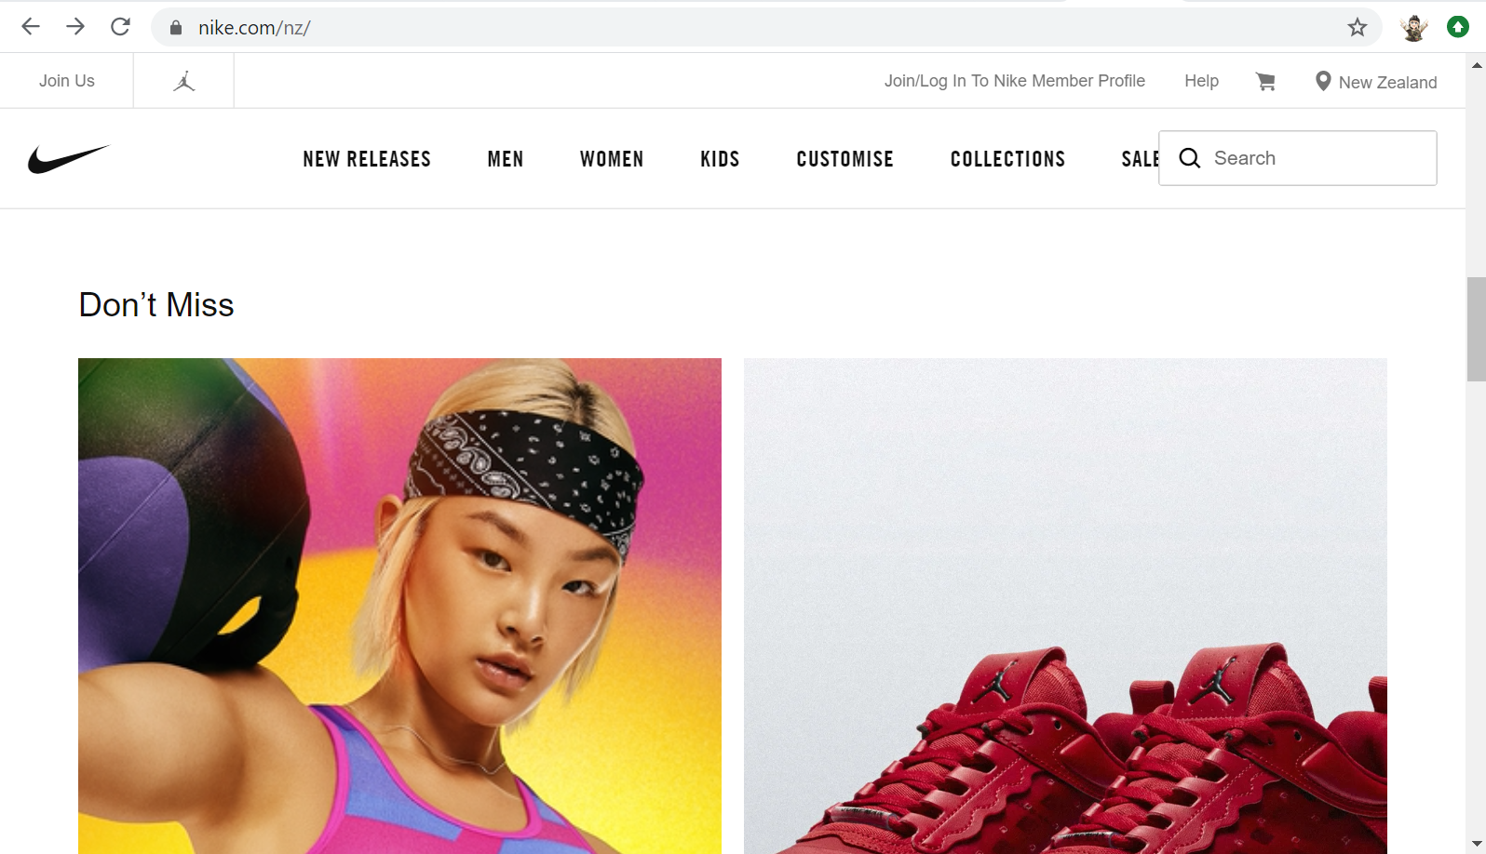

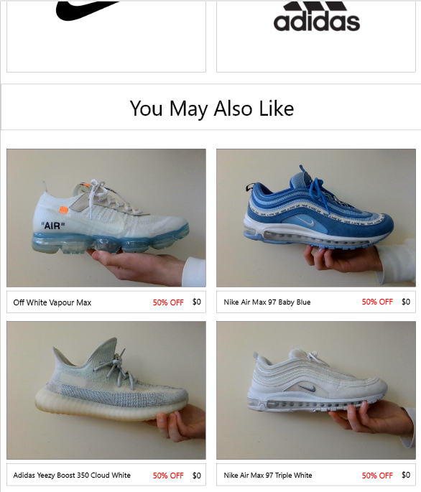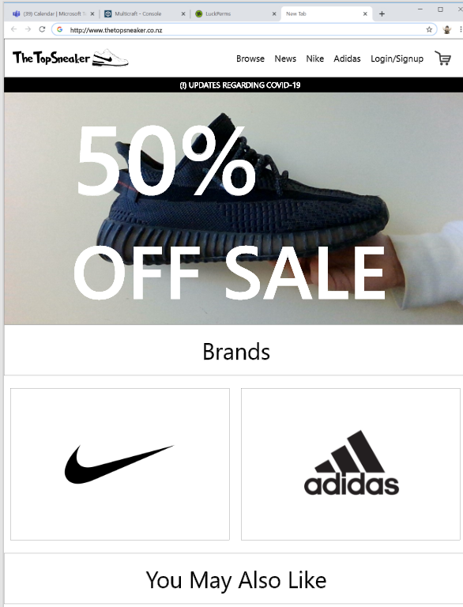**First Design:**

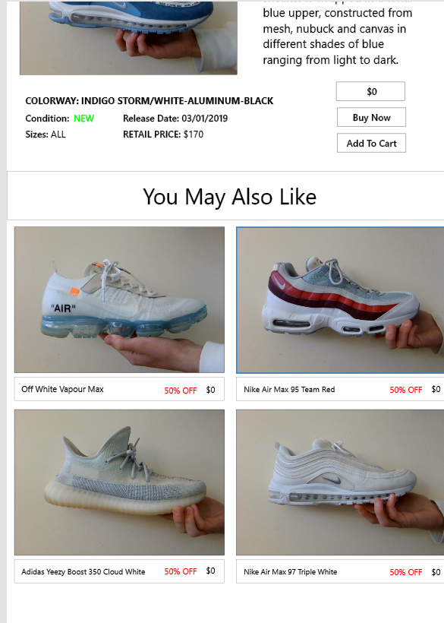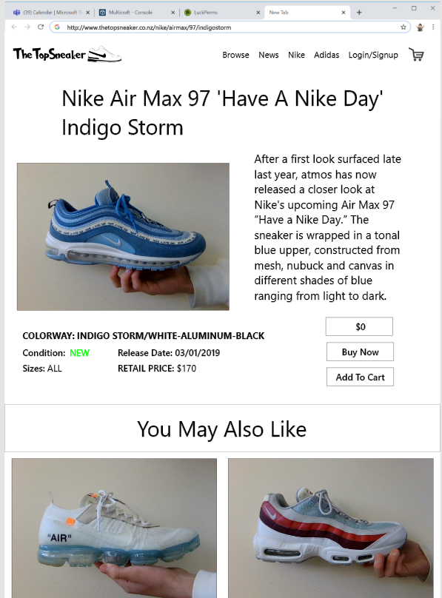

**Feedback from first design:**

1. On product page the name of the product they suggested I make it fit as the same with as the image.
2. On product page add 3 rows of the shoes because now it looks like the page is to skinny and would not fit the whole screen of a desktop.
3. Add a purchase page, give an example what that would look like etc

**After first feedback**

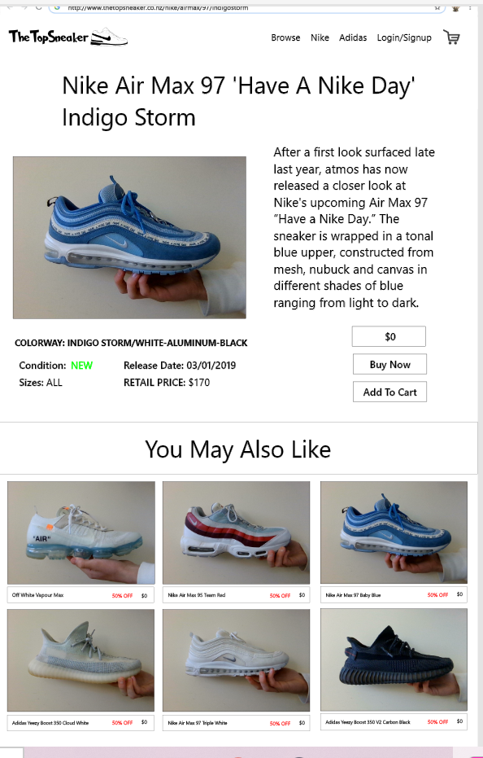

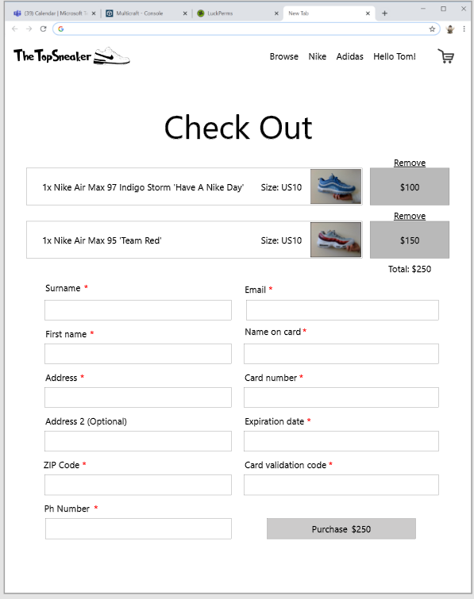

**Feedback**: The people that looked at my site thought there was not anything else I needed to add. It had the main features a retail site required and looked good. Some personal feedback I thought for my second design I want to add more colour and try make it less plane like this design is.

**2# First design:**

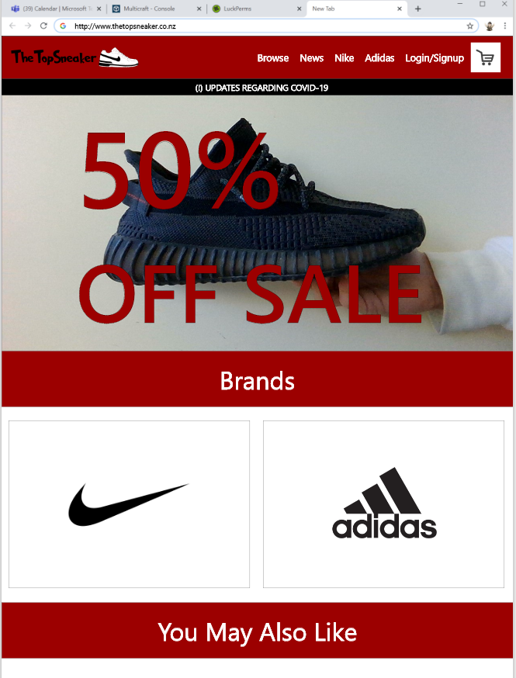

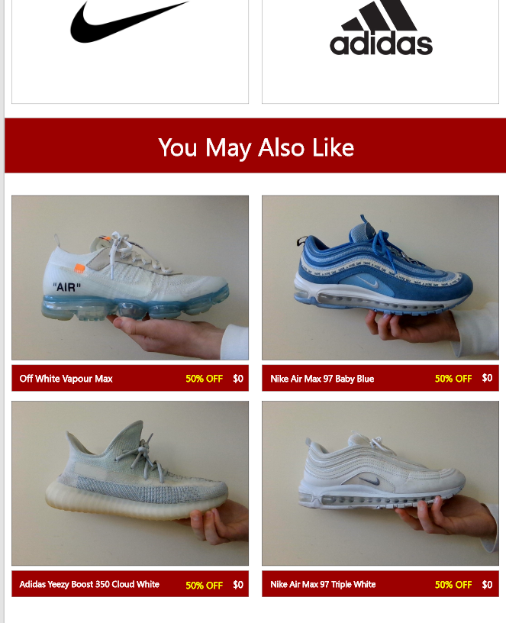

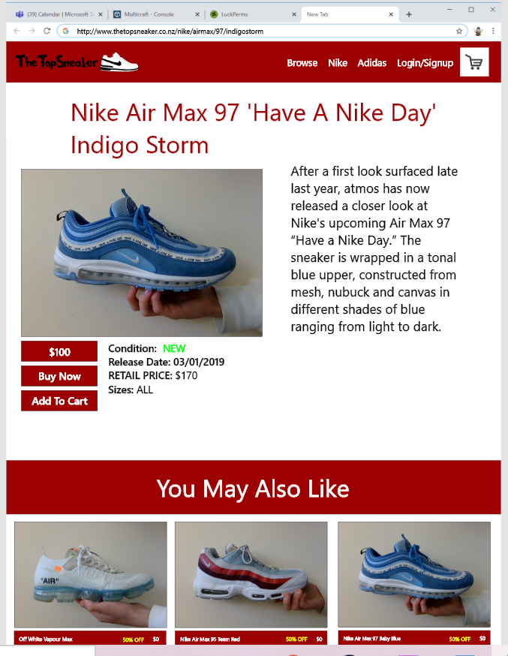

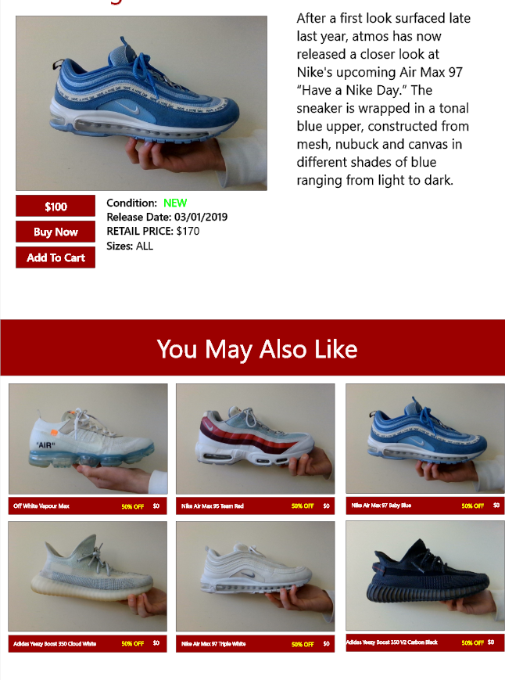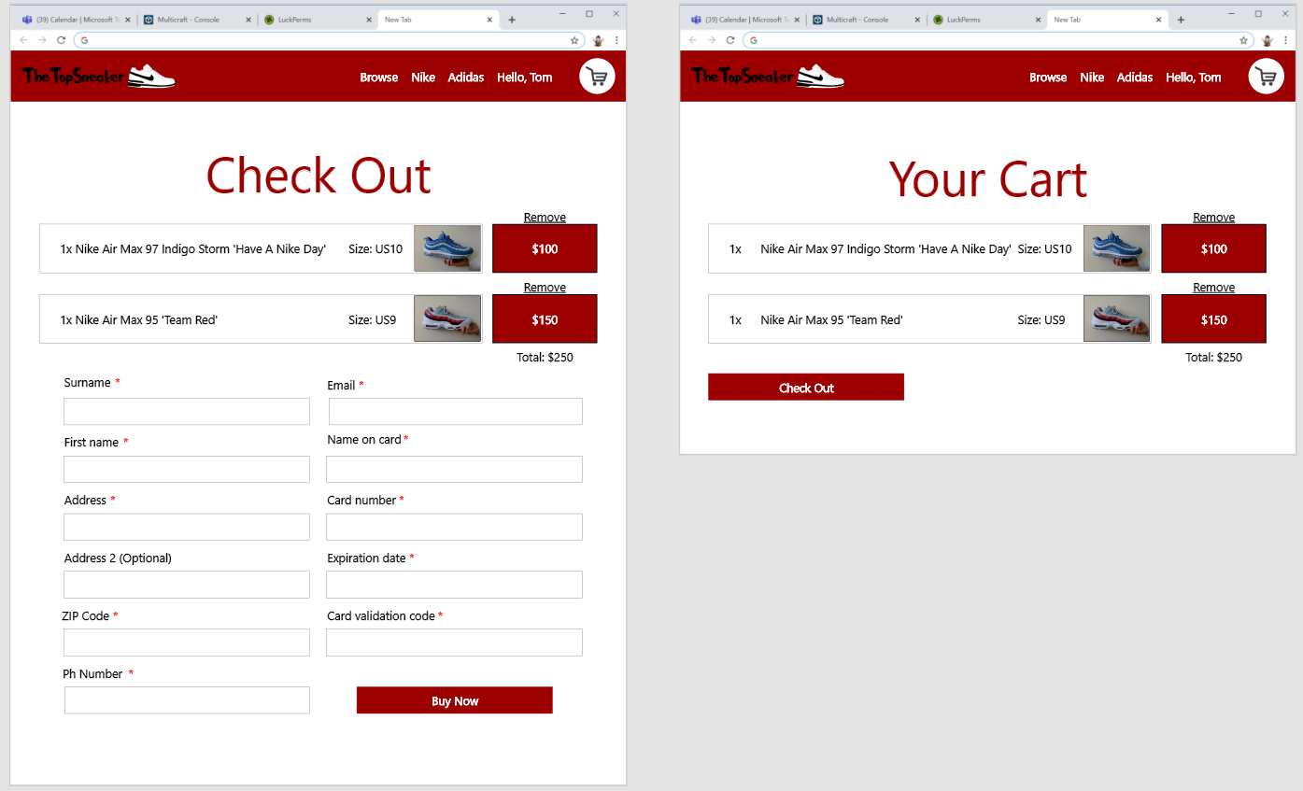

**Feedback:** I did not receive much feedback as they were happy with how my site looked. They suggested I look at using a different colour for the 50% sales as the yellow does not contrast well with the red. Also suggested I edit the logo to make the text white as that will contrast better with the red as the black is hard to read.

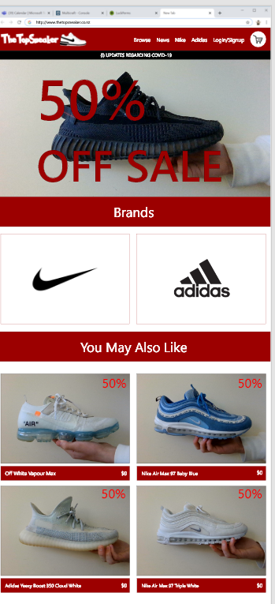

**Feedback:** After changing the 50% off displays everyone that looked at my site was happy with the layout and how it looked so I think I am ready to put this design into my html.

**Stage 4: Testing**

**Evidence of user testing and feedback**

**Date:** 9 June

**Who tested:** Allen

**Feedback:**  Site looks good. He could not find any way to break it. Fully functional.

**Date:** 6 Jun

**Who tested:** Allen

**Feedback:**  When you go to the cart with an empty cart it does not display the cart is empty only broken SQL

**Date:**5 Jun

**Who tested:**Allen

**Feedback:**Still need to fix some error catching, if you change the ID of brand or product to an invalid variable the SQL breaks displaying a whole bunch of errors.

**Date:**5 Jun

**Who tested:** Phil Adams

**Feedback:**When logging in you can enter a blank usernames and reuse usernames that have already been taken.

**Date:**4 Jun

**Who tested:**Tyler

**Feedback:**The brand name is not correctly displayed when you change the brandID (on brand page)

**Date:**3 Jun

**Who tested:**Tyler

**Feedback:**If you go to the cart page without logging in first the cart page breaks (recommended I make it so the user is forced to login first then they can go to the cart page.)

**Date:**1 Jun

**Who tested:**Maree Burnett

**Feedback:**Recommended I have a space between my products, so they do not feel as cluttered.

**Final summary and evaluation**

**Trello:** See Trello Folder for evidence of this

Throughout my project I used the recommended service Trello. This website allowed me to track my progress throughout this huge internal and break it down into smaller size chucks that seemed doable at each stage. At first, I thought the app was useless and not necessary but after using it throughout my project I think I will continue to use it because it really did help with my time management skills. Through the process of my internal I have been updating each task as I started then completed it. I found that it made the process easier of my internal easier for me to be able to break it down into smaller sizes. If I had not used Trello for my assessment, I think I would have struggled with my time management skills and may have not completed the huge amount of work that needed to be handed in. I think I would have left more work later and maybe not even have finished, but by using Trello its almost like ticking off an achievement each time you add something to doing and then move it to done, this created self-motivation and self-satisfaction when completing each small task of this internal.

**Adobe XD:** Throughout the design process I used XD to design my website and help me imagine what I wanted my site to look like. This made a huge difference to may site because I got to be able to get what I had in my head and display it on a website. It also helped me to gain heaps of feedback and act upon that feedback, this is because I could easily make changes to edits to my site when someone recommended something. I think without this program I would have struggled to get the design I wanted and to the quality it is now. This program allowed me to create a end product I am happy and proud of. On the feedback side of XD, I found extremely helpful because you can just share boards (your work) with your classmates so they can give feedback on your site for you to make improvements. Overall, I am extremely thankful we got to use this program because it made my design process a lot easier to complete at a high level.

**Photoshop:** Throughout my design process I used photoshop to create logos, edit and resize images and edit icons for my site. This was a huge help for my project as I could make and edit anything that I wanted for my design which means I my design is a lot higher quality than it would have been without it. I also used illustrator, which is another very similar program to photoshop, mainly used this for recolouring logos to fit for what I wanted on my site.

**My end user requirements were:**

1. Be able to look through all the shoe items that are available
2. Be able to register an account with my site safely (Having passwords hashed in case someone hacked my database)
3. Be able to login to an account that a user had created from registering an account
4. Be able to save items to your cart that are saved to your userid so when you log out the items are still there for when you log back in
5. Be able to remove items from your cart, individual and all items.
6. Be able to purchase items then it removes all the items from your account once you have purchased them so you can continue shopping
7. Be able to browse individual brands such as Nike and Adidas, also allows me to add more brandID’s and they will just attach to the site without me needing to code anything else

**Conclusion:** My final website successfully meets the end user requirements because it has all these features working correctly. The user is able to browse across my store, see what is recommended for them, register and login to accounts, save items to their cart, remove items from their cart (individual or all), browse individual brands they wish to see, and purchase items.

**Relevant Implication Website No.1:** Usability

For the first relevant implication, I have made sure to have a consistent layout based upon my research I made during the design phase. This allowed my site to have a sense of familiarity when a user comes onto my site because it is very similar to other ecommerce stores you may find on the internet. This meant I had things like my navbar, products and shopping cart in similar places to Nike and Adidas so they do not feel alienated when coming onto my site, they just view it as another online store. I made sure my site was easy to use and made the user feel confident when browsing my site because of that sense of familiarity. I also have all possible user errors corrected so if a user does create an error such as a wrong password or using a password someone else is already using they will be explained the reason for it and how they can fix that error.

**Relevant Implication Website No.2:** Aesthetics

From the start I wanted my design to look good but to be simplistic so the user can easily navigate throughout my site without becoming confused where all my content was on my site. I achieved this by using a colour scheme that has contrasting colours that look good to the eye, all my text is easy to read and in general I think the website looks goods. Because of the XD I was able to gain feedback from potential users which helped me improve and perfect my designs which resulted in a good-looking final design. Overall, my design is rather simplistic because it only has the main needs for a ecommerce store without throwing heaps of content at the user that is really just unneeded and could course the user to feel over whelmed. I think my design represents The Top Sneaker brand quite well and I would not have designed it any differently.

**Relevant Implication Database No.1:** Functionality

Through endless planning, I have been able to make my database fit into my websites purpose through successful execution, now having the database connected to my website is vital. My main end user requirements were to filter brands, enables my cart and user accounts (adding productid’s to an userID so their content can be saved in their cart even when they log out.) Therefore, my website must have a database that is correctly designed, and I think I have done a good job of that. All tables and every variable are being used so I think this relevant implication was a success.

**Relevant Implication Database No.2:** Legal

This relevant implication was very important for my website because I will be selling items to my users. They expect that the content I am selling them is my own, so I needed to think about the legal aspects of running an ecommerce store. I have designed my own logos through photoshop, I have also taken all the photos that are on my website and even the shoes on my website I own also so it is all original content and does not break any legal laws. I think I have achieved this relevant implication successfully because my site only uses my own content and I have not taken any content from other sources.